**Firmware Flashing Steps – GG11-LTE-M-SSK**

**Prerequisite**

* Install SimplicityCommander-Windows:

<https://www.silabs.com/documents/public/software/SimplicityCommander-Windows.zip>

SimplicityCommander is required to program the Flash memory of GG11-LTE-M-SSK board.

* Verify MD5SUM as per below
  + 3cd1787b1e0cfffa89f112e542a6dbfe - bootloader-storage-internal-single-2048k-combined.s37
  + Dc71784c0231cc7c753db556d99814f4 - aws_demo-signed.s37

**Binary flashing**

**Bootloader flashing**

1. Plugin debug cable as well as power cable to the GG11-LTE-M-SSK board
2. Open command prompt in windows.
3. Go to the directory where simplicity commander zip is extracted using command prompt.
4. Apply below command to erase chip, this should give message **DONE**
   1. **$ commander.exe device masserase**
5. Open Simplicity commander GUI by below command
   1. **$ commander.exe**

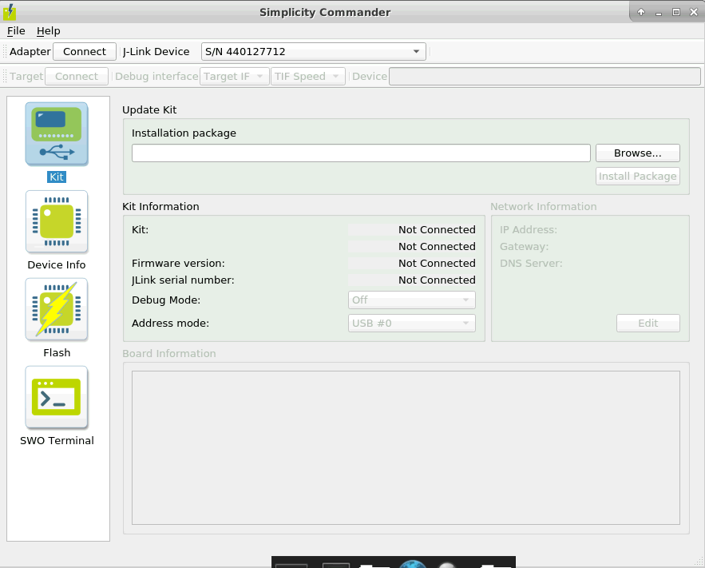

1. Click **connect** from top left side in **Adapter**
2. Click **connect** from top left side in **Target**

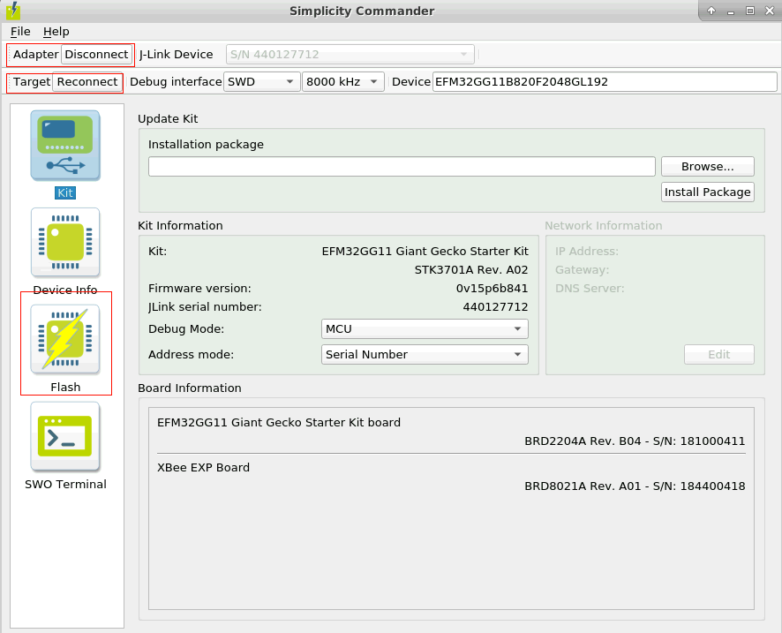

1. Go to **Flash** from left button icons
2. **Browse..** the bootloader file from Prebuild Images/bootloader/bootloader-storage-internal-single-2048k-combined.s37 local pc and press flash button
3. Go to **SWO** **terminal** icon button from left side and click start to see bootloader logs
   1. **NOTE - As no valid apps are available it should fail in logs**

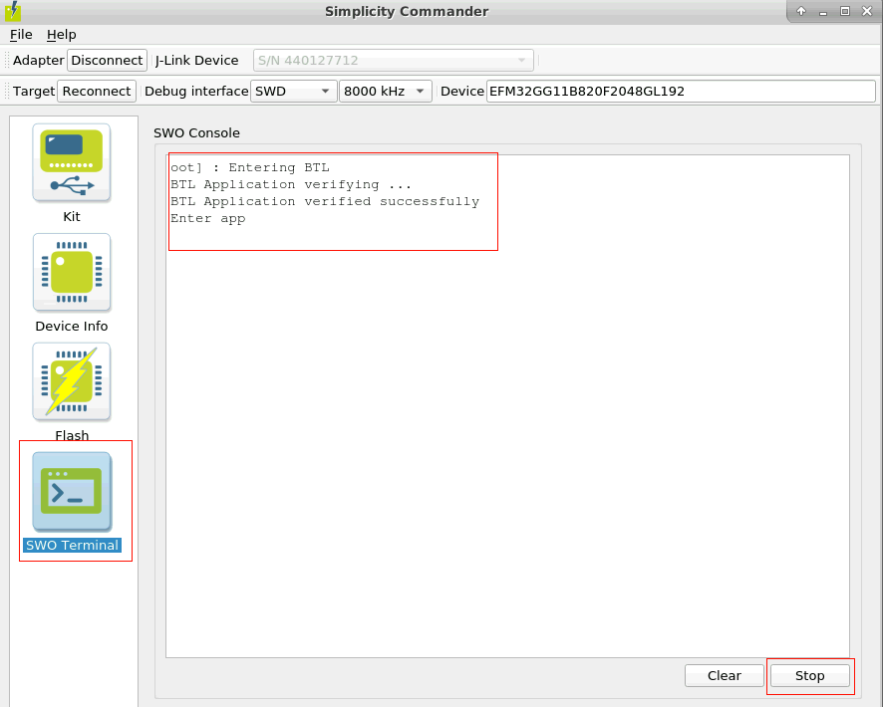

**Application flashing**

1. Close Commander GUI and apply below command to flash app and its signing tokens from Prebuild Images/mqtt_demo
   1. **$commander.exe flash --tokengroup znet --tokenfile encryption-key --tokenfile signing-key-tokens.txt**
2. Again, go to commander GUI by below command
   1. **$commander.exe**
3. Click **connect** from top left side in **Adapter**
4. Click **connect** from top left side in **Target**
5. Go to **flash** from left button icons
6. **Browse..** the bootloader file from Prebuild Images/bootloader/aws_demo-signed.s37 local pc and press **flash** button
7. Open serial terminal console and application logs should appear

**Please refer Quick_Start_Guide_GG11-LTE-SSK_vXX-.docx**